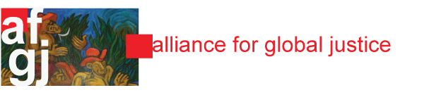

October 12, 2023

Published by the Nicaragua Network, a project of Alliance for Global Justice!

Spectacular Advances in Health in 2023!
By Nan McCurdy and Katherine Hoyt
(This article first appeared in the UK publication The Morning Star.)
(Nan McCurdy is the editor of NicaNotes. Katherine Hoyt is the former editor (now retired) of the Nicaragua News Bulletin and the Nicaragua Network Hotline.).
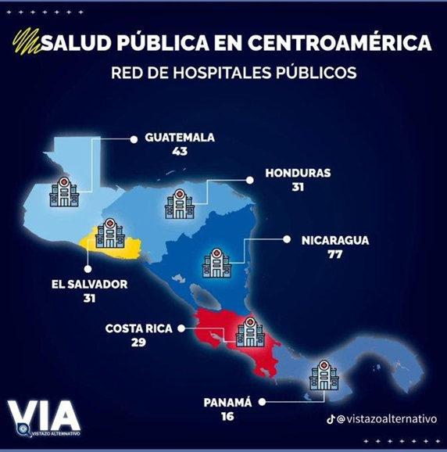
Nicaragua made some spectacular advances in health care so far this year. The country has done very well in Covid vaccination compared to most countries in the Americas. The Pan American Health Organization reported in June 2023 that with 94.7% of the population fully vaccinated (two shots) against Covid-19, Nicaragua is the country in Central American with the highest percentage of fully vaccinated population. Nicaragua is known for its regular vaccination campaigns. For example, during the National Influenza Vaccination Campaign, 594,000 doses were administered, for a 99% compliance with the goal.

Nicaragua has by far the most public hospitals in Central America, especially if compared by population. Nicaragua, with a population of 6.61 million, has one public hospital for every 85,844 people. However, Guatemala, with a population of 18.71 million, has one public hospital for every 418,604 people; Honduras has one public hospital for every 331,935; El Salvador one for every 204,516 people; Panama one for every 274,375 people; and Costa Rica one for every 180,344. (Sources: Vistazo Alternativo and https://www.statista.com/statistics/1399508/population-of-central-america-by-country/
The Ministry of Health will also vaccinate girls aged 10 to 12 against the Human Papilloma Virus to prevent cervical cancer, said Deputy Andrés Zamora, member of the Health Committee of the National Assembly. Dr. Zamora highlighted vaccination coverage in in 2023. “As every year, we carry out massive vaccination days between April and May, and this year we are going to introduce a vaccine against the human papilloma virus for girls between 10 and 12 years of age, which would mean 18 vaccines (according to age) that are applied free of charge to the entire population,” said Zamora.
On Jan. 30 the organization Accreditation Canada announced that the Alejandro Dávila Bolaños Military Teaching Hospital, maintains the highest level of accreditation for the fourth year in a row. It also received the Excellence in Safety Quality Award for the third year in a row and the People-Centered Care Commitment Prize, consolidating its position as the only hospital in Latin America and only the second in the world, to receive these three levels of accreditation.
Nicaragua has built 26 new modern public hospitals since 2007 and has some 15 more on the way. It also has the most hospitals of any country in Central America. The construction of the hospitals in Leon, Nueva Segovia and Bilwi in the Caribbean are advancing quickly. One example is the US$72 million that is being invested in the Nueva Segovia Departmental Hospital which will have 236 beds and five operating rooms where 40 surgeries will be performed daily. The Japan-Nicaragua Friendship Hospital in Granada was rebuilt and expanded with an internal medicine unit, operating room, and intensive care unit, benefiting 206,000 inhabitants from four municipalities.
Two new high-tech operating rooms were inaugurated early this year at the Bertha Calderón Women’s hospital. Fetal surgeries as well as surgeries on pregnant women with cancer can be performed. The operating room has high-tech intelligent audio and video systems for watching live fetal surgery. There is an amphitheater for training purposes. Ministry of Health specialists performed three successful fetal surgeries there in September on pregnant women from three Departments. The women had twin pregnancies with a complication called Feto-Fetal Transfusion Syndrome and Selective Growth Restriction, which if they had not undergone surgery, one or both babies would have died due to growth alterations. So far, 188 specialized fetal surgeries have been performed successfully.
Since 2013, the government has promoted the strategy of maternity wait homes to reduce perinatal maternal mortality. Currently there are 181 maternity wait homes to assist women in the final period of their pregnancy and maternal mortality has been reduced by 70% (infant mortality has been reduced by 56%). The women are mainly from rural areas. The mayor of Ticuantepe, Dr. Ligia Ramirez, said that the strategy is to have at least one maternity wait home in each municipality because there are people who live in places that are not close to health centers and there they can be seen by doctors. The wait homes are near hospitals or a well-staffed health center.” Ramirez said. “Here they come to rest, to de-stress and also to receive timely medical attention.
This strategy has led to a decrease in maternal mortality,” she added. “The women can come here two weeks before [their due dates] and sometimes they can stay for more than a month, depending on their condition,” she noted. Among the benefits they receive are lodging, food, and education on subjects such as
self-esteem, women’s rights, risks during pregnancy, and newborn care. The maternity waiting homes have a staff dedicated to the care of pregnant women 24 hours a day.
More than 5,000 mainly Indigenous women were attended by health care providers in a Mega Health Fair in Bilwi in the North Caribbean. Sixty maternal and fetal specialists provided attention to the women. The Ministry of Health carried out the Healthy Women Campaign between Jan. 16 and March 2, with 2,008,433 services provided for women including 3,692 surgeries, 12,626 specialized care services, 18,426 breast ultrasounds, and 15,654 mammograms.
Mobile Clinics bring quality medical care to families every day. In May specialists provided consultations to the residents of the Francisco Meza neighborhood of Managua, part of the famous Eastern Market. “We are in this health fair that is quite busy to provide different medical services with excellent attention to the population. We also provide medicines,” said Dr. Eduardo Corea.
The mobile clinics have transformed the lives of Nicaraguans: people can get ultrasounds and other tests, dental care along with consultations. Resident Blanca Hernández said, “The clinics are very important. I no longer have to go to the health center because we get attention and medicines right here in the neighborhood. I feel very grateful to my government for all it does for us since these things are not seen in other countries and here everything is closer to our homes and without paying a cent.”
Nutrition is important for good health. The 2023 Nutritional Census surveyed 1,425,806 boys and girls from birth to 14 years, between January and May of 2023 and found amazing results. From 2022 to 2023, acute malnutrition of children between the ages of birth to 6 years was reduced 9.3% and chronic malnutrition fell 8.2%. Acute malnutrition between the ages of 6 and 14 fell 13% and chronic malnutrition was reduced by 4.3%. With this data, programs like Zero Hunger, Family Gardens, School Lunches, Food Production Packages, and the Family Support Plan will be strengthened to continue reaching nutritional goals.
The Ministries of Education and Health reported that, with the National Healthy Schools Plan, 2,929,304 consultations have taken place as of June 29. According to that bulletin, 525,721 minors have had their blood pressure measured, detecting 659 with problems; 514,678 eye exams were done, identifying 5,694 children with a need for eyeglasses; 455,899 talks were given to students, parents and teachers on personal hygiene care. Similarly, 448,694 language evaluations were performed, detecting 4,179 children with speech problems; 450,712 hearing evaluations were performed, detecting 4,485 with hearing disorders. Specialists carried out 277,639 checks to identify head lice, delousing 93,963 students; 255,961 demonstrations were given on good tooth brushing technique and 24,540 students had cavities filled.
In the first half of the year, specialists at the Dr. Clemente Guido Oncology Center for Chemotherapy and Palliative Care, inaugurated in 2020, provided 44,166 free consultations to 12,998 patients from all over the country suffering from different types of cancer. According to a report, 26,420 chemotherapy sessions, 9,451 palliative cancer care sessions, 3,083 nutrition sessions, 2,640 pain clinic sessions and 2,572 psychology sessions were provided.
On July 18 the expanded Regional Epidemiological Laboratory for Managua was inaugurated to handle the tuberculosis and HIV areas with high technology equipment. The expansion consists of two areas for tuberculosis with molecular biology equipment that will allow timely diagnosis, cultures and investigations, as well as the HIV area for confirmation tests, CD4, virology studies and other studies. Dr. Domingo Castro Olayo, director of the Laboratory, said that this expansion is important to be able to make timely diagnoses of the diseases in order to treat and provide efficient management to patients. This laboratory has a trained team of clinical laboratory technicians and will serve all the municipalities of the Department of Managua.
As part of the Special Love and Care for our Elderly Program, from February 15 to August 2, 2023, 907,492 health care services were provided to seniors. Over 300,000 seniors were informed about the importance of physical exercise and maintaining a healthy diet in house-to-house visits. They were also presented with the booklet “Love and Care for our Elderly.” Over 200,000 people who suffer from chronic diseases received check-ups and medical attention; 173,893 of them participated in meetings to promote adherence to their medication and special care by the family nucleus. Over 125,000 seniors received attention for the early detection of complications; 60,500 specialized medical attentions were provided to those who presented some alteration in their usual state of health.
Specialized attention was received by 4,625 women during the mega health fair held August 26 at the Jacinto Hernández Primary Hospital in Nueva Guinea, South Caribbean. The patients had consultations with specialists according to their condition. They came from 350 communities and 76 neighborhoods of Muelle de los Bueyes, El Rama, El Coral and Nueva Guinea. The specialized care provided included 10,254 ultrasounds, 748 Pap smears and readings, 479 laboratory studies, 360 procedures for the diagnosis of pre-malignant lesions of the cervix and 26 surgeries. A meeting was also held with members of the Community Health Network to identify aspects to be strengthened in the implementation of the Family and Community Health Model.
Also in August, the Ministry of Health delivered an aquatic ambulance to serve the families of the Indigenous communities of the Tawira and Prinzu Auhya Un Territories. The ambulance will provide better care for people who need to be transported from their community to the Bilwi Hospital in the event of an emergency situation.
On Sept. 9 and 10, the Ministry of Health carried out the first health fair in the Miskito Cays, where doctors provided attention to nearly 4,000 people living in these small islands of the Nicaraguan North Caribbean. Doctors performed ultrasounds, Pap smears, special blood chemistry tests to detect kidney disease, electrocardiograms and specialized care for pregnant women and women in general, as well as internal medicine, dermatology, general surgery, urology and also completed the vaccination schedule, including COVID-19. Indigenous leader of the Tawira Territory Nildo Amasio Abisal said that this is the first time that a fair of this magnitude has been held in the Miskito Cays. He said that many patients were transported to the point of care in boats.
As of September 10, the Health Ministry has provided 701,189 child health care services this year as part of the activities of a national plan to monitor the nutritional status of children under 6 years of age. Over 400,000 house-to-house and school visits were made, where children received vitamins and parasite medication. More than 72,000 children who were identified as suffering from malnutrition are receiving follow up attention to improve their nutritional status. Through the National Nutritional Status Follow-up Plan, 8,024 pregnant women are being followed due to low weight gain. And 60,116 members of the Community Network were trained and certified to identify children with nutritional problems in order to promote healthy lifestyles.
The Ministry of Health reported that 4,129 health care services were provided to some 2,000 people from the municipalities of Corn Island, Laguna de Perlas, Kukra Hill, Desembocadura del Río Grande, El Tortuguero and Bluefields, in the South Caribbean Autonomous Region during the orthopedic fair held on September 22 and 23 at the Dr. Ernesto Sequeira Blanco Regional Teaching Hospital in the city of Bluefields.
The women in the Special Indigenous Territory of Alto Wangki, inhabited by the Mayagna and Miskito peoples, were taken first in canoes across the rivers and then by bus to a Mega Health Fair where 15,943 health care services were provided to 6,716 people. The Fair served communities from the municipalities of La Concordia, San Sebastián de Yalí, San Rafael del Norte, Wiwilí, Santa María de Pantasma, San José de Bocay, El Cuá, Jinotega, and from the Special Indigenous Territory of Alto Wangki. Specialized care included 3,809 ultrasounds, 628 pap smears and readings, 590 laboratory studies, and 88 surgeries.

